PPMS New User Request

Instructions for requesting PPMS Access

Contents
Pre-requisites for obtaining HMS PPMS Access 4
1. Have you been in touch with the core director or core staff in the core you plan to use? 4
No, I have not been in touch with the core director or core staff in the core I plan to use 4
Yes, I have been in touch with the core director or core staff in the core I plan to use 4
2. Are you planning to request access to any of the following facilities? 4
3. My core is not listed for access 4
4. Important Note 4
PPMS User Account Creation Form Instructions 5
Go to the HMS PPMS Start Page 5
Confirm approval for access to a core 5
PPMS User Account Creation Form 6
PPMS user account creation form instructions 6
Selecting your group 7
My group is not on the list 8
Complete the Group information 8
Group Management Request 8
Submit form 9

Pre-requisites for obtaining HMS PPMS Access

1. Have you been in touch with the core director or core staff in the core you plan to use?
If you would like to obtain access to the HMS PPMS cores management system, please let us know if have you been in touch with the core director or staff of the core you would like to use.

No, I have not been in touch with the core director or core staff in the core I plan to use
If you answered NO, please contact the relevant core to request access before filling out a user creation form. You can find the list of HMS research core facilities and their websites here: https://corefacilities.hms.harvard.edu.

Yes, I have been in touch with the core director or core staff in the core I plan to use
If you answered YES, further instructions for HMS PPMS and core access are provided in this document.
2. Are you planning to request access to any of the following facilities? You can either select the link on this page or go to the HMS PPMS Start Page at https://ppms.us/harvard-hms/start/ and click the relevant HMS core facility. You need to select the correct core, otherwise access will probably not be granted.
- Analytical Chemistry Core (ACC) details
- Bio-Nuclear Magnetic Resonance (BioNMR) details
- Center for Macromolecular Interactions (CMI) details
- Harvard Center for Comparative Medicine (HCCM) details
- Harvard Cryo-EM Center for Structural Biology (CryoEM) details
- Molecular Electron Microscopy Suite (MEMS) details
- Nascent Transcriptomics Core (NTC) details

3. My core is not listed for access
If the core you wish to access is not listed above, it is not currently using the new HMS enterprise PPMS system. Please contact the core directly to request access to the appropriate scheduling system. You can find the list of HMS research core facilities and their websites here: https://corefacilities.hms.harvard.edu.

4. Important Note
Please plan ahead! After you submit a request for access to the HMS PPMS system, it might take two to three business days to create a fully verified new user account. If you have an urgent need for core access, please email ppmsadmin@hms.harvard.edu, and in the subject line, please write: ‘Urgent PPMS access requested.” You should have filled in a new user account creation form (see below) and submitted it before sending an urgent access request email.

PPMS User Account Creation Form Instructions

Go to the HMS PPMS Start Page
https://ppms.us/harvard-hms/start/ and click on the link to the appropriate core facility.
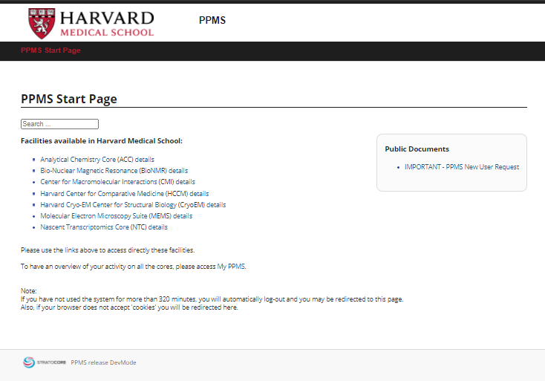
Pick the facility that you are planning to use at Harvard Medical School by using this link: https://ppms.us/harvard-hms/start/

Confirm approval for access to a core
Once you have been approved for access by the core director or core staff and have navigated to the PPMS link for that core, click ‘Continue’ at the bottom of the PPMS page for that core.
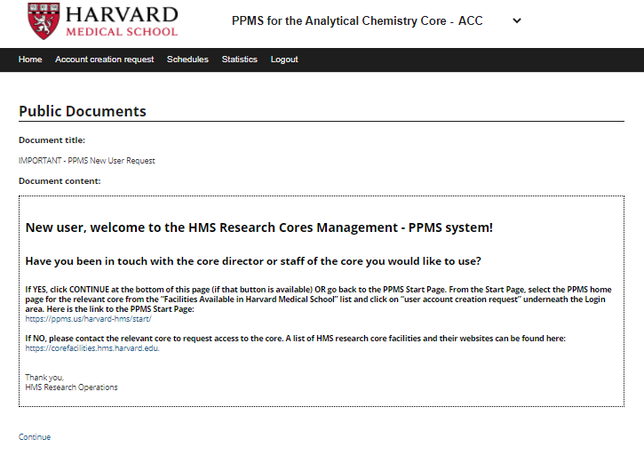

PPMS User Account Creation Form
You will now be at the PPMS user account creation form for the specific core facility that you have chosen. If, at this point, you want to change the core, you can do so by clicking on the name of the correct core at the top of the page.
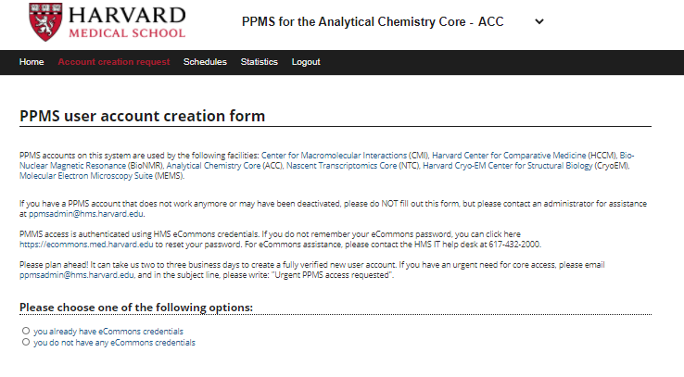
If you need to change the core, click on the name and you will be redirected to their core page

PPMS user account creation form instructions
Please use the below chart to review the required steps
If you already have eCommons credentials | If you do not have an eCommons credential
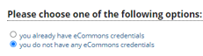 | 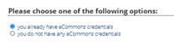
You will be directed to eCommons log in page
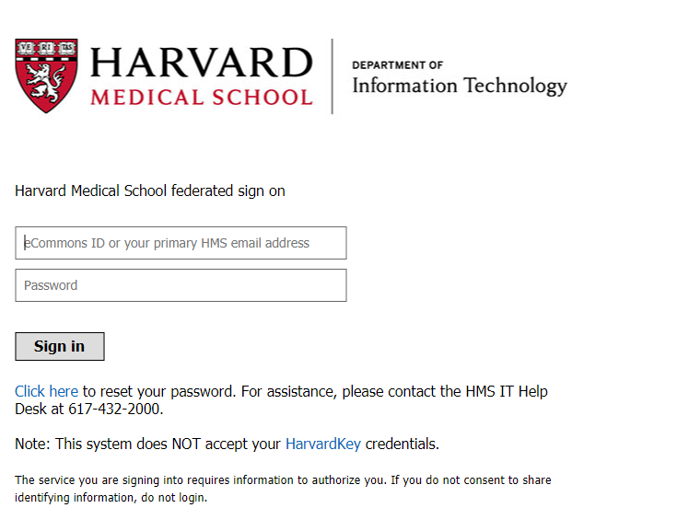
When you fill in the eCommons credentials and sign-in, you can now see the PPMS account creation form, pre-filled with your eCommons ID. | Fill in the PPMS account creation form that appears below.
- First Name, Last Name, Phone, and Email are required
- HUID – if you have a HUID please enter the information here
- Lab Group (PI) – required
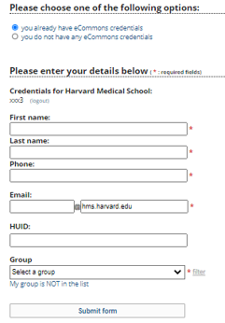 | 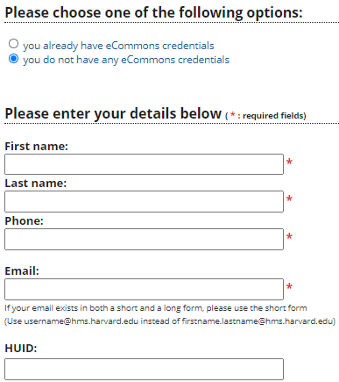

Selecting your group
You can select a lab/PI group by using the pick list.
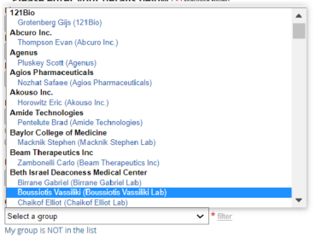
You can also find the group by typing the name in the “filter” box.
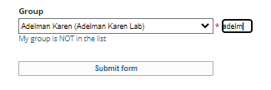

My group is not on the list
If you cannot find your group, please click on the ‘My group is NOT in the list’ button.
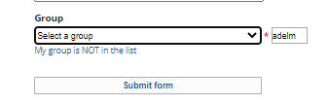

Complete the Group information
Please complete all of the group information. Group administrator information is mandatory. If you will be using a PO, please ensure that the default PO and Invoicing address is included.
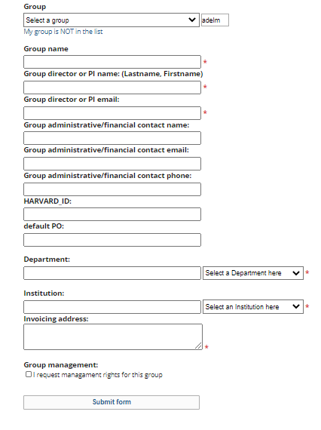

Group Management Request
If you are a grants manager or grants administrator, you may request management rights for this group.

Submit form
Once you have completed the form, click the ‘submit form’ button and the form will be automatically routed to the HMS PPMS admin team for review and completion.
You will receive email notification when your PPMS access has been granted. Following that, the core director or core staff will contact you to provide more information about core-specific PPMS user rights and responsibilities.

